**Tree Based Algorithm Lab 3 Tree Traversal (Paths)**

**Document Id 37**

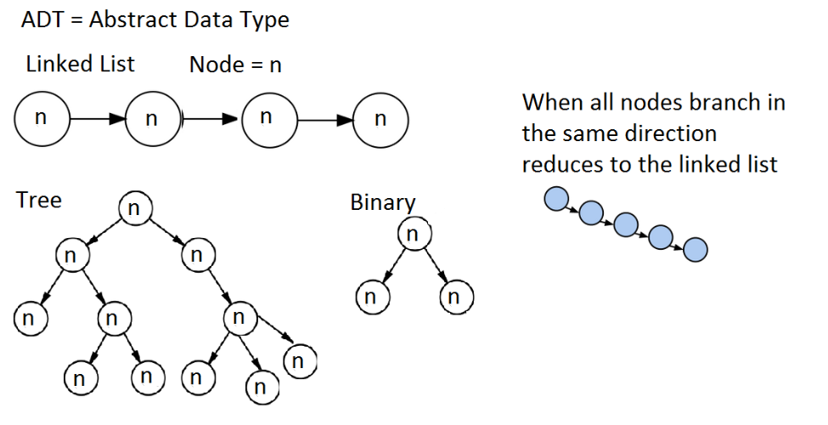

**Questions**

Q1 name three important attributes of a hashing function

Q2 defie “collision” w.r.t hash functions

Q3 why is modular hashing popular

Q4 Define AVL tree

Q5 Define rotations as they apply to AVL trees

**Practical Task Calculate Paths**

Extend the AVL tree we created to include a method that prints all possible paths

when traversing the tree